**Technical Document Mini POS**

**v1**

**TABLE OF CONTENTS**

Entity Relationship Diagam (ERD) 3

Activity Diagam 4

Use Case Diagram 5

**Entity Relationship Diagram**

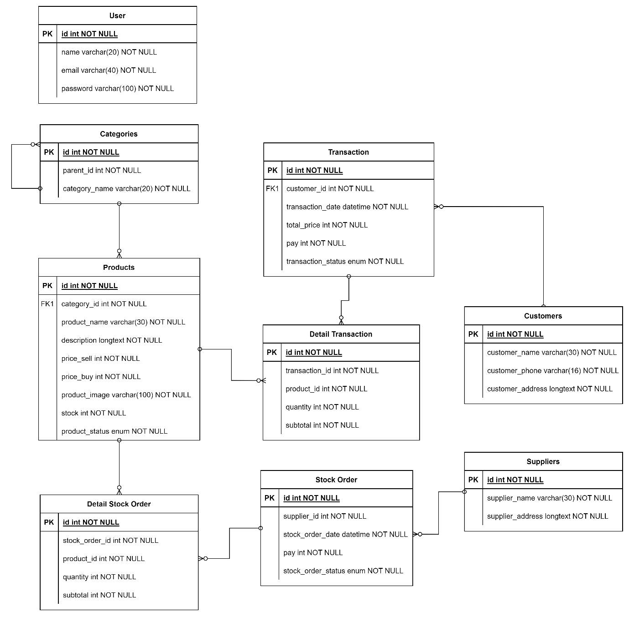

**Activity Diagram**

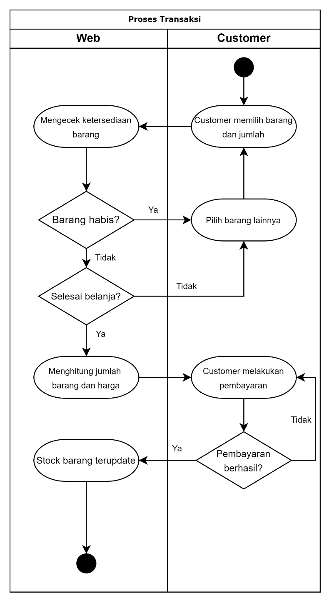

**Use Case Diagram**

